Paper Title (Use style: Paper title)
Times New Roman; Size-16; Line Spacing: single spacing; Paragraph Spacing: Above paragraph-10pt, Below paragraph-10pt

First Author¹, Second Author², Third Author³
¹First Author Affiliation & Address
²Second Author Affiliation & Address
³Third Author Affiliation & Address

ABSTRACT (maximum 300 words)

Purpose: The purpose of this article is to give network administrators the information and abilities they need to successfully traverse the intricacies of network management. It starts by going through the application stack and explaining the roles and relationships between each layer. The Ninja template engine is then described, along with an explanation of how its potent grammar makes network configuration management simple.
Materials and Methods: The research design employed in this study is a combination of qualitative and quantitative approaches. It involved an extensive literature review to gather existing knowledge on network automation and management practices. Additionally, empirical data was collected through surveys and interviews with network administrators to understand their experiences, challenges, and perspectives on network automation.
Findings: The study found that network automation offers numerous benefits, including increased efficiency, reduced human errors, and enhanced network security. The application stack was identified as a critical component of network architecture, and its proper management can significantly impact network performance. The Jinja template engine proved to be an effective tool for simplifying network configuration tasks and promoting standardization across the network infrastructure.
Implications to Theory, Practice and Policy: The study was informed by the "Network Automation Theory," which posits that automating network management tasks can streamline operations, enhance reliability, and free up human resources for more strategic initiatives. To network administrators and practitioners, we recommend staying updated with the latest advancements in network automation technologies and tools. For policymakers, we propose the formulation of a comprehensive policy framework that encourages the adoption of network automation technologies
Keyword:. (Maximum 5)
Add JEL Codes

1.0 INTRODUCTION (Maximum 2 pages) ( Heading 1 (CAPITAL LETTERS- Paragraph Spacing: Above paragraph-15pt, Below paragraph-5pt)
A project for open-source network automation built on Nornir, Scrapli, and FastAPI is being developed. construction of a cutting-edge open-source network automation project. The central idea of this project is to automate as much of the configuration, management, operation, and troubleshooting of network devices as possible using technologies like Nornir, Scrapli, and FastAPI. (Casoni, Maurizio;) The effective administration of network infrastructure is essential for enterprises of all sizes in the quickly changing technology world of today. Traditional manual techniques for managing networks frequently show to be time-consuming, prone to mistakes, and challenging to scale. Our goal is to improve the way network devices are managed by utilizing the capabilities of automation tools and providing a more effective and scalable method.
1.1 Problem Statement (Maximum 1 page) (Heading 2 (Title Case- Paragraph Spacing: Above paragraph-5pt, Below paragraph-5pt)
Insert a section on problem statement.
State the “what is the problem?’ Who gets affected and how do they get affected? Why is it important to conduct this study (in other words, do knowledge gaps exist that justify the study?

2.0 LITERATURE REVIEW (Heading 1 (CAPITAL LETTERS- Paragraph Spacing: Above paragraph-15pt, Below paragraph-5pt)
2.1 Theoretical Review (Heading 2 (Title Case- Paragraph Spacing: Above paragraph-5pt, Below paragraph-5pt)
Mention Theories that underpin your research. For each theory ensure there is a classical author/contributor of the theory. Other contributors/proponents or critiques-What does each theory state? Give the major principles/tenets of the theory. The contribution to the current study. Link the theories to the study.

2.2 Conceptual Framework (Heading 2 (Title Case- Paragraph Spacing: Above paragraph-5pt, Below paragraph-5pt)

Conceptual Framework
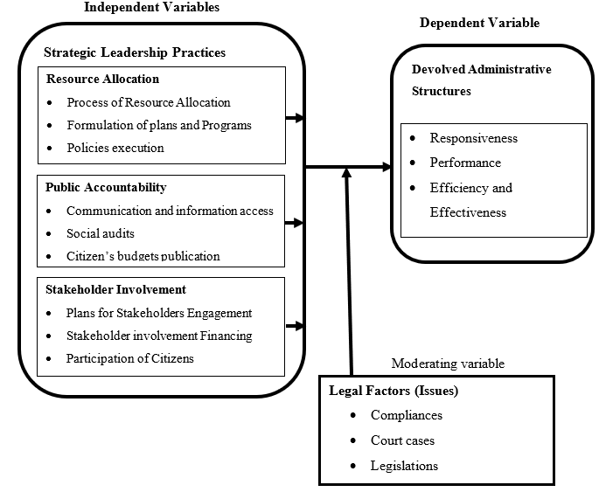
Figure 1: Conceptual Framework
Source; Researcher (2023)
2.3 Research Gaps(Heading 2 (Title Case- Paragraph Spacing: Above paragraph-5pt, Below paragraph-5pt)
Insert 1 paragraph showing the research gaps identified from the studies reviewed, which the study sort to fill.

3.0 MATERIAL AND METHODS (Heading 1 (CAPITAL LETTERS- Paragraph Spacing: Above paragraph-15pt, Below paragraph-5pt)
(Below should be in one paragraph)
Study Design: Descriptive, explanatory, Prospective open label observational study
Study Location: Where the study was carried out
Population: The study target population
Sample and sampling techniques
Data Collection: Questionnaires etc
Statistical Analysis

4.0 FINDINGS ( Heading 1 (CAPITAL LETTERS- Paragraph Spacing: Above paragraph-15pt, Below paragraph-5pt)
Present your findings.
Tables (The table headings should be bolded, capitalized each word, times new roman 12 and justified)
The figures in the tables should all be centered.
The word “Total” and the figures on the same row should always be bolded.
Positioning Figures and Tables: Place Figures and Tables at the top and bottom of columns. Avoid placing them in the middle of columns. Large figures and tables may span across both columns. Figure captions should be below the figures;
table heads should appear above the tables. Insert figures and tables after they are cited in the text. Use the abbreviation “Fig. 1,” even at the beginning of a sentence.

Table 1: Response Rate (Heading 2 (Title Case- Paragraph Spacing: Above paragraph-5pt, Below paragraph-5pt)
Response | Frequency | Percent
Returned | 174 | 77.3%
Unreturned | 51 | 22.7%
Total | 225 | 100%
Diagrams
All diagrams should be labelled and centered.
They should be clearly labelled as Figure 1: or Figure 2: and the labelling should be in italics and capitalized each word.

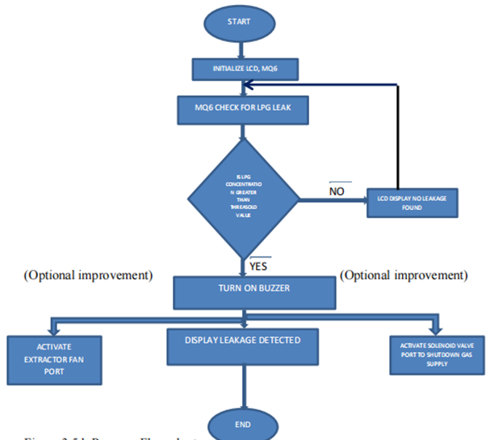

Figure 2: Program Flow Chart

5.0 CONCLUSION AND RECOMMENDATIONS (Heading 1 (CAPITAL LETTERS- Paragraph Spacing: Above paragraph-15pt, Below paragraph-5pt)

5.1 Conclusion (Heading 2 (Title Case- Paragraph Spacing: Above paragraph-5pt, Below paragraph-5pt)

5.2 Recommendations (Heading 2 (Title Case- Paragraph Spacing: Above paragraph-5pt, Below paragraph-5pt)

6.0 REFERENCES (Should be in APA and each should have a DOI link) ( (Heading 1 (CAPITAL LETTERS- Paragraph Spacing: Above paragraph-15pt, Below paragraph-5pt)

Varghese, T., Kang, G., & Steele, A. D. (2022). Understanding rotavirus vaccine efficacy and effectiveness in countries with high child mortality. Vaccines, 10(3), 346. https://doi.org/10.3390/vaccines10030346

Acknowledgments and Conflicts of Interest Declaration.

